**Digital Marketing**

1. Create a blog or website using Blogspot and WordPress. Customize the theme design and post new article with 500 words.

<https://kiddiecaravan.blogspot.com/>

1. Create a New Facebook Business Page and post one social media poster for your brand.

<https://www.facebook.com/kiddie.caravan?mibextid=ZbWKwL>

1. 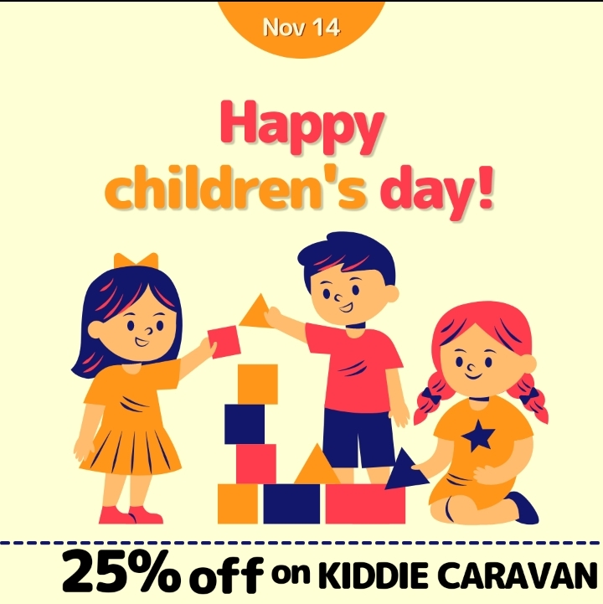Create and design a social media advertisement poster using canva.
2. 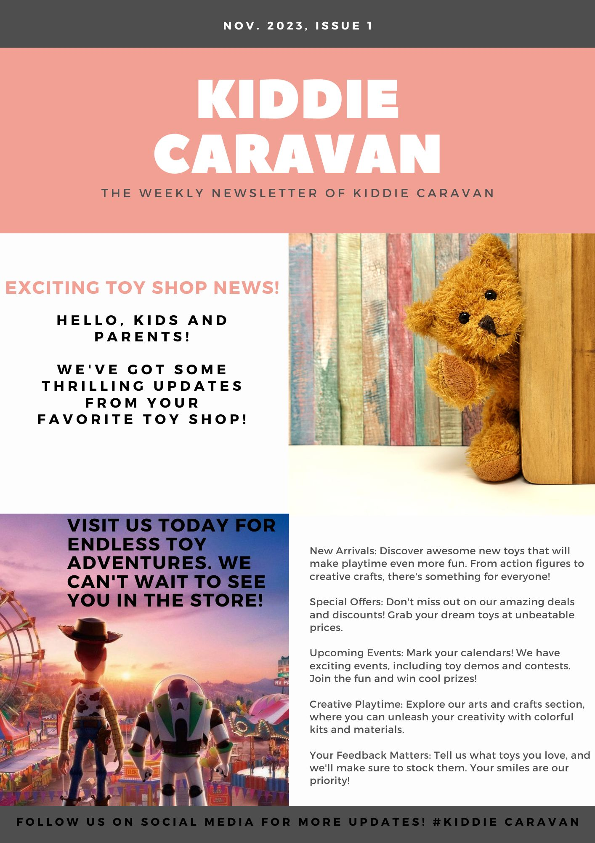Create email newsletter design using MailChimp or canva tool.